**DLD STEM ICE – Week 1 Tuesday AM**

***Complete these problems on a separate piece of paper.***

1. Convert the following logic gate diagrams into Boolean expressions, keeping track of the subexpression at the output of each gate.

a.

A*B

A*B+C

(A*B+C)*!D

!D

b

!A

!(!A*B*C)

!A*B

1. Sketch the logic gate diagrams for the following Boolean expressions (do not simplify the expressions yet!): -> refer to paper

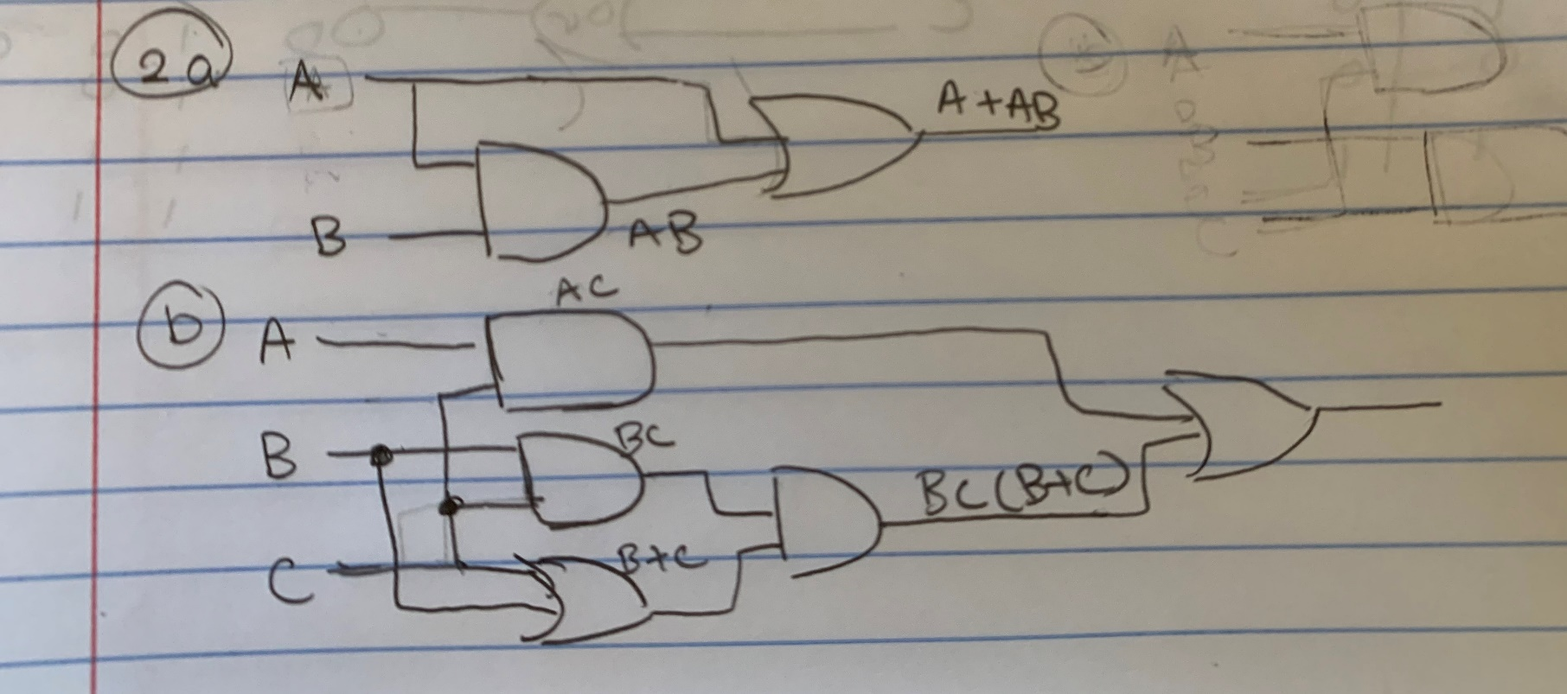

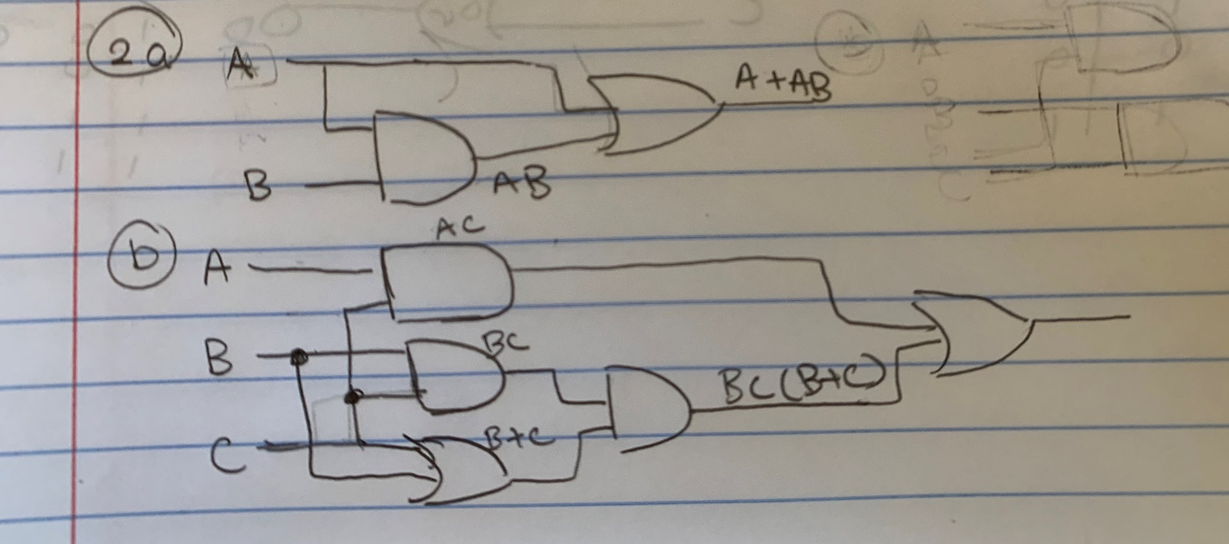

* 1. 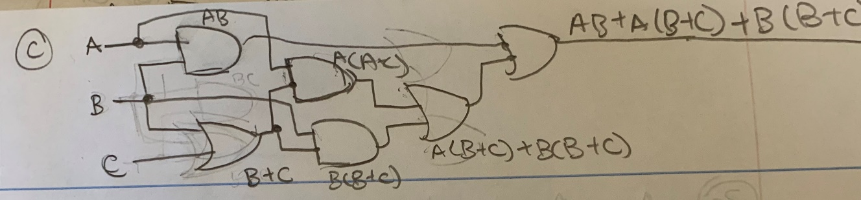

1. Now use the rules and laws of Boolean Algebra to simplify the following Boolean expressions:
   1. **->** A(1+B) -> A(1) -> **A**
   2. -> AC + BBC + BCC -> AC + BC + C -> AC+BC -> **A(C+B)**
   3. -> AB + AB + AC +BB + BC -> AB + AC +B +BC-> A(B+C) + B -> AB + B + AC (reordered) -> B(A+1) + AC -> **B+AC**

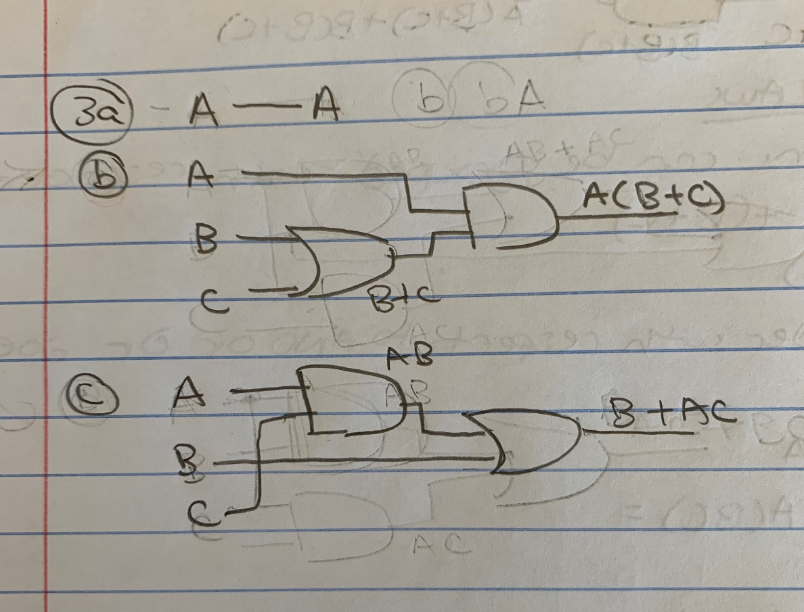

1. Use DeMorgan’s Theorem to simplify the following Boolean expressions:
   1. -> !A+!(!B!C+BC)-> !A+!(!B!C)*!(BC) -> **!A +(B+C)*(!B+!C)**
      1. !A+B!B+B!C+C!B+C!C -> **!A +B!C +C!B**
   2. -> **A+B+!C+!D**
2. 3-variable K-Map

Consider the Boolean expression:

* 1. What size K-Map will this expression need?

3 variables -> 2^3 = 8

* 1. Use a K-Map to find the simplified Boolean expression.

|  |  |  |  |  |
| --- | --- | --- | --- | --- |
| **A\BC** | **00** | **01** | **11** | **10** |
| **0** | 1 | 1 | 1 | 0 |
| **1** | 1 | 1 | 0 | 1 |

!A!B!C + !A!BC +A!B!C + A!BC -> !B

!A!BC + !ABC -> !AC **-> !B +!AC + A!C**

A!B!C + AB!C -> A!C

* 1. Sketch the simplified circuit diagram.

